
Beckingham Primary School
The Limes Beckingham Doncaster Yorkshire DN10 4QN

Telephone: 01427 848230
office@beckingham.notts.sch.uk

Headteacher: Mrs E J Moore B.Ed (Hons)

23 February 2021

Dear Parents

Going back to school on Monday 8 March 2021

The briefing at 7.00 pm last night by Boris Johnson was a positive pathway (we hope) out of Covid-19 restrictions.

Firstly, we expect all children to return to school unless their consultant has told them they must not or you suspect your child has Covid-19 or someone in your household does. School in March will have some resemblance to ‘normal’ school but it will also have some very important safety measures in place.

We will continue with our safe drop off and pick up times. Please adhere closely to these for every ones safety. If you cannot remember your family’s times please email the school office before starting back on 8 March. We know these times are not perfect for everyone, but we feel arriving as a family group will be quicker than class times. We also ask that you do not stand or walk away in groups with other parents/carers.

Your child will continue to be in their class bubble. Each bubble will play together at playtimes and eat lunch together in their classrooms. We would like to encourage all children to have a school dinner. The school lunch menus are on our website under the heading ‘Parents’. Lunch boxes will have to be kept in classrooms and we cannot therefore keep them cool. All children will also require a full (large) water bottle. These cannot be refilled during the day because it would mean the bubbles being broken. Bubbles will not mix.

We expect all children to be wearing full, clean and washed school uniform, we continue to ask that you send children in trainers, not school shoes. We do not require PE kit. As our hall will still be out of action, we intend doing PE outdoors whenever the weather is fine, with the children wearing trainers we feel we can do this at the drop of a hat. We will provide you with plenty of warning for when we do require school shoes and PE kit.

Only one adult to drop off and collect the children at the end of the day. If your child previously came and left by themselves this can continue. However, if you would like your child to start doing this for the first time, as the nights are getting lighter, please email the school office.

All children will enter the school site through the blue pedestrian gate on The Limes at both the beginning and end of the day. This ensures we can closely monitor who is entering the site. Please only enter the site at the end of the school day, unless you have a child in Foundation but please collect your oldest child first.

For the children in Foundation and Class 1 we will adhere to social distancing in the classrooms as best we can. We will endeavour to space all the children out around their rooms. As soon as the children enter the building they will wash their hands, they will do this again every time they enter and leave their allocated classroom.

We would like to encourage children to only bring their book bag to school. Year 5 and 6 children may bring a small rucksack instead.

We are hoping the children may begin swimming again soon. We will let you know as soon as we know.

If you have any questions or concerns please email your child’s class teacher.

Foundation rbrumby@beckingham.notts.sch.uk

Class 1 ssteeper@beckingham.notts.sch.uk or nward@beckingham.notts.sch.uk

Class 2 ckearns@beackingham.notts.sch.uk or head@beckingham.notts.sch.uk

Class 3 khamilton@beckingham.notts.sch.uk or cgreen@beckingham.notts.sch.uk

Things to remember:

PLEASE DO NOT PARK ON THE LIMES

- Only send your child to school if they are well.
- Adhere to your chosen drop off and pick up times. If you cannot remember your family’s times please email the school office before 8 March.
- Only one adult to accompany your child/ren to school.
- Children in Year 1 to Year 6 enter the site on their own.
- Foundation are brought to their play area.
- Wear school uniform and trainers (not school shoes).
- PE kit not required at the beginning of term.
- Bring a large filled water bottle.
- Encourage your child to have school dinners.
- Only bring your book bag (Year 5 and 6 may bring a small rucksack).

Yours sincerely
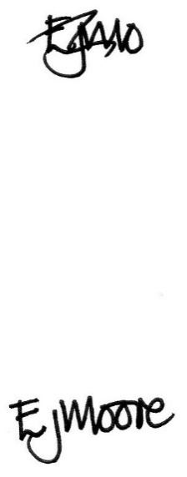

E J Moore
Head teacher

