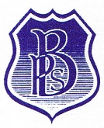
Beckingham Primary School
The Limes Beckingham Doncaster Yorkshire DN10 4QN

Telephone: 01427 848230
office@beckingham.notts.sch.uk

Headteacher: Mrs E J Moore B.Ed (Hons)

27 May 2020

Parents of children in Year 2, 3, 4 and 5

Dear Parents
You will have seen in the news that the government would like schools to aim to start back on or near the 1st June. I will be writing separately to parents who are key workers and to those who have children in Foundation, Year 1 and Year 6. I thought it best to keep you informed of what is happening in school.

The governors, staff and I have formulated a plan, and only if we can return safely, will we do so. In school we cannot guarantee two metres social distancing for the children.

I have been in school to measure our classrooms and their contents including tables and other furniture. We will need to remove most of the furniture to ensure we can space the children out and make their return to school as safe as possible. School will be a very different place for children, staff and for you as parents when we finally return.

We shall continue to supply work packs, for those not able to attend school because they are not children of key workers, in the designated year groups or due to medical reasons, or for parents who prefer to keep their child at home.
If you have any concerns or questions, please e mail me at head@beckingham.nott.sch.uk
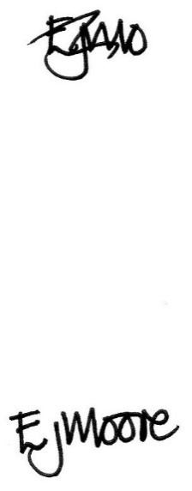
Yours sincerely

Liz Moore
Head teacher

