
4 October 2019
Years 1 - 6
Dear Parents

Relationship and Sex Education sessions

At Beckingham Primary School Relationship and Sex Education (RSE) is an integral part of our Personal, Social and Health Education (PSHE) provision for children. Government guidance recommends that children are prepared to deal with the transition to adulthood in an age appropriate way within the moral and values framework of the school. The SRE we provide also helps to safeguard our pupils.

As in previous years, we have invited a trained facilitator to deliver Relationship and Sex Education workshops to our children in years 1-6 on 11 October 2019. The details of each year group’s provision is given below:
Year 1/2 – Differences and similarities between themselves and others, naming body parts (including words penis and vagina), parts of the body that are private, good/bad touches and who can help.
Year 3/4 – Introduction to puberty changes.
Year 5/6 – Puberty changes girls/boys, families of all kinds, consent, reproduction within the context of loving relationships, healthy relationships, internet safety.
The content of the sessions will be delivered using a variety of methods including group activities, discussion and appropriate excerpts from teaching videos. The sessions are designed to equip your child with the knowledge and skills to enable them to keep safe and deal effectively with the transition to adulthood. It is hoped that parents and carers will discuss their child’s learning with them at home to further their understanding. Support for talking to your child can be found here: https://www.fpa.org.uk/help-and-advice/advice-for-parents-carers
The session will be in line with legislation and good practice guidance set out in the government’s SRE Guidance 2000 and the Equalities Act. The facilitator has enhanced DBS clearance and a member of school staff will be present at all times during the session to enable follow up work within the school.
Due to the nature of the session, children may ask questions and these will be answered in an honest and factual way appropriate to the age of the children involved. The workshop will be delivered in line with the school’s policy on Relationship and Sex Education.
We hope that you are supportive of the school’s approach to this issue and would welcome you to contact us if you have any comments or concerns. In line with legislation you have the right to withdraw your child from Relationship and Sex Education that takes place outside of national curriculum Science. If you would like to exercise this right, please contact the Head Teacher.

Yours sincerely
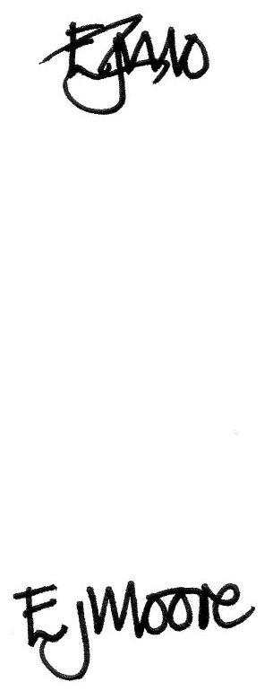

E J Moore
Headteacher

