
16 November 2018

Classes 2 and 3 – Years 3 to 6

Dear Parents

Key Stage 2 ‘Alice in Wonderland’

The KS2 performances are on Wednesday 12 December at 2.00 pm and 7.00 pm and Thursday 13 December at 7.00 pm. Due to fire regulations everyone requires a ticket and we have a limited number available for each performance.

This year the tickets will be £2.00 and all money raised will be used for children’s activities within the curriculum. Please complete on your sQuid account how many tickets are required for each performance. We are limiting the amount of tickets per family to up to 5 tickets (i.e., 5 maximum not 5 per performance), to try and be fair to all. This DOES NOT guarantee you will get the full five places. As in previous years, they will be available on a first come-first served basis.

You will need to add the total number of tickets required to your basket and then proceed to checkout. Once at checkout please select the date and answer how many tickets for each performance (you will not be able to checkout and pay until the questions have been answered).

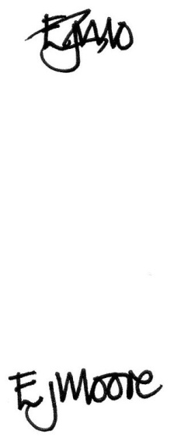
Yours sincerely

E J Moore
Head teacher

