sQuid SchoolPay Guide

You may have noticed a Trips Purse added to your sQuid account, located to the right of the catering purse.

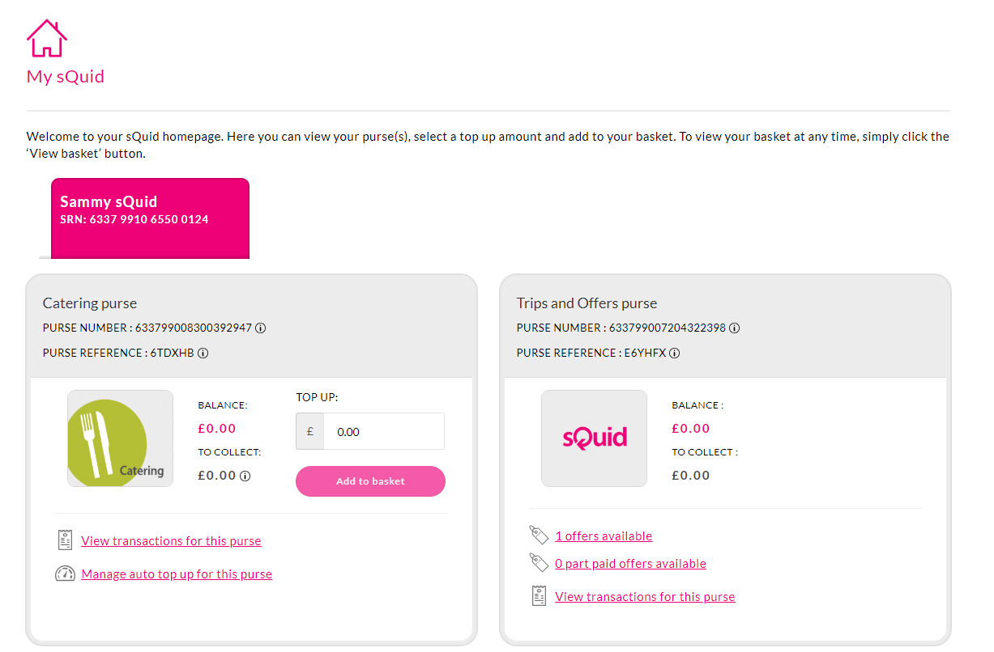

If you have more than one child registered with sQuid, select the relevant child to proceed.

The trips purse will then display any relevant offers (e.g 1 offer available)
Click on the offers available, this will then display the offers available to purchase. Add the desired offer to the basket.

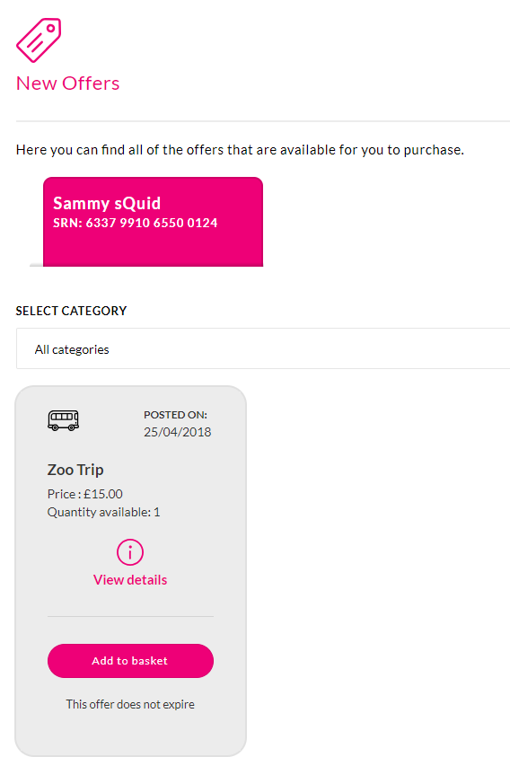

If you would like to purchase the offer click on Add to basket and you shall be shown a confirmation. If happy to proceed click on Add to basket to proceed.

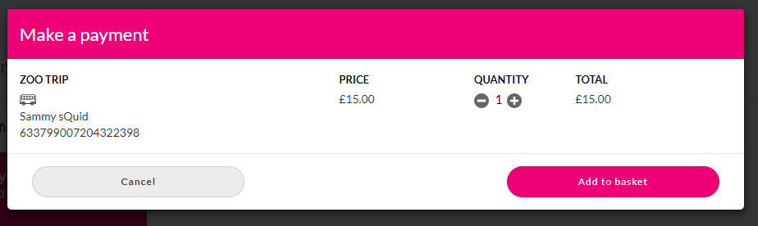

From Home Screen

Click view basket, if you are happy with the contents of the basket click checkout.

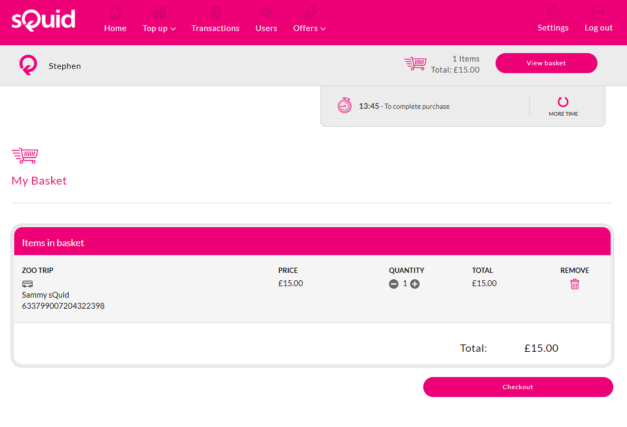

Additional Information

Your school may have added additional information for you to read or complete, this will have to be completed before you can complete your purchase.

*If you do not complete the required fields you will not be able to click the next tab.

Once completed click finish.

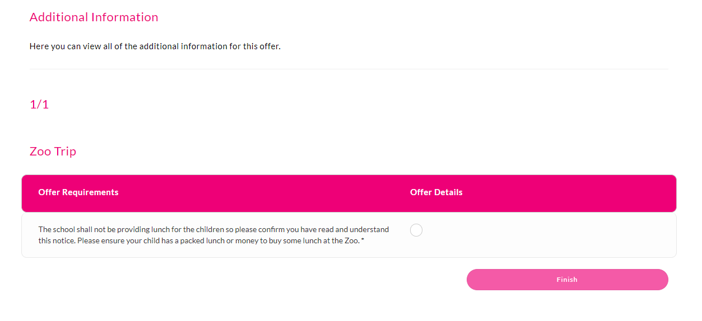

Offer Summary Page

The offer summary displays the details of your purchase and an option to checkout.

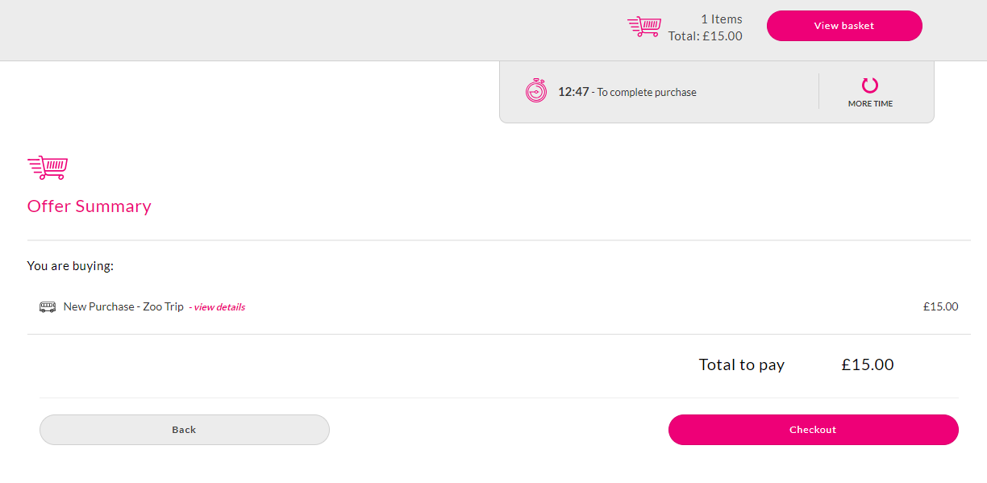

Checkout

Select Card type and proceed with payment.



