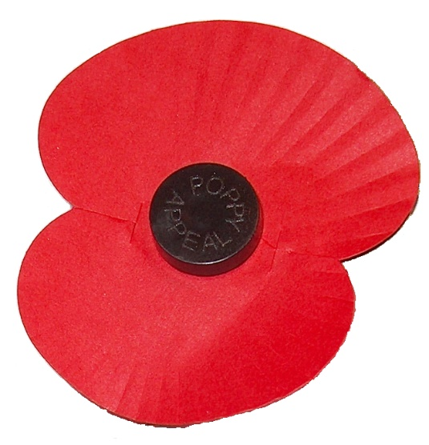
Rememberance Day Menu
Friday 10th November 2017
Menu
Nottinghamshire sausage & gravy
Or
Quorn sausage & gravy
Mashed Potatoes
Sliced carrots
& garden peas
Dessert
Poppy cookie
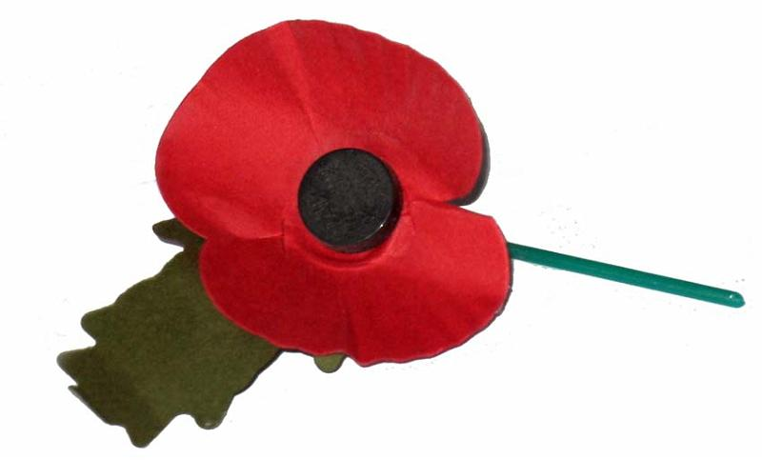
& strawberry milkshake

