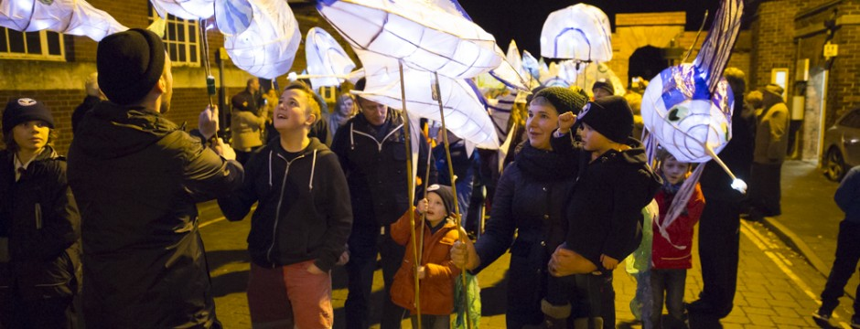
RE: Retford’s Illuminate 2017 Lantern Parade – Briefing for parents

Dear Parent / Guardian,
Your child has recently taken part in lantern making workshops for Retford’s first Illuminate lantern parade in November 2017.
We are really excited to be holding this year’s parade on behalf of Bassetlaw District Council. We will be commemorating Bassetlaw’s role in the Mayflower story and Pilgrims’ heritage through twinkling lanterns and music.
Your child’s part in the parade will be key in creating this atmosphere so we will welcome the enthusiasm and energy they have brought to the workshops on the day of the event.
To ensure that you are fully prepared for the event please find some key details below:

Event date: Tuesday 21st November 2017

Performance: Talegate Theatre perform ‘Chronicles of the Mayflower Pilgrims’, 4pm, Retford Town Hall

Parade route: Retford Town Centre – from Carolgate to Retford Market Place

Parade start: 5pm in Carolgate (from the pedestrianised area furthest from the Market Place)

Parade end & collection point: 5.45pm in Retford Market Place, DN22 6DR
Your child will be a part of a procession starting from the end of Carolgate (near Wilko’s) and finishing in the Market Place. Carrying the paper flame lanterns they made at school, they will walk in line accompanied by school staff through to the Market Place, directed by Bassetlaw District Council staff, marshals and artists who have worked on the project. Your child will be brought to the event accompanied by school staff to watch a performance in Retford Town Hall at 4pm. We will leave Beckingham school at 2.45 pm and travel by coach. They will then be accompanied by school staff to the parade start for a 5pm start. Once all participants have arrived we will line up ready for the procession. We would encourage you to come and watch the event. Your child can then be collected from the Market Place at 5.45pm once the parade ends.
Dress:
Please make sure that your child is appropriately dressed for the weather conditions expected on the evening. We will provide a white tabard to be put over winter coats. Warm layers, a waterproof coat, and a hat and gloves are recommended.
Parade timings:
We will leave Carolgate at 5pm. The procession will arrive in the Market Place at 5.15pm where participants will be directed around the Square to see each other’s lanterns and some entertainment. The event will end by 5.45pm. The children will remain in their designated area. Once the entertainment has finished, the children will be moved into a holding area in their school and community groups and then you will be able to meet your child at the Event Desk near the Town Hall.
Photographic and video consent:
At the event, there will be a number of people taking photographs on behalf of Bassetlaw District Council. Please complete and return the below photographic consent to let us know if you are happy for your child’s photograph to be taken.
Contact:
Children will be given a wristband for the event which will record the name and contact number of the person responsible for collecting them after the parade. Please include these details below. Please note, these details will not be retained by Bassetlaw District Council.
All participants must return these forms to their teacher before Monday 20th November.

We look forward to seeing you all on the 21st November!
Kindest regards,

Anna Scott

Heritage Consultant

Bassetlaw District Council

www.pilgrimroots.org | www.mayflower400uk.org

Photo consent

I, the parent/guardian of: ……………………………………………………………………………... give/DO NOT GIVE permission for Bassetlaw District Council to take photographs and video footage of the above named participant at Retford’s Illuminate Festival on Tuesday 21st November 2017.
I am happy for these photos to be used within the following in relation to Bassetlaw District Council and its Pilgrim Roots project: social media, website, newsletters, press releases, project evaluation, and future event marketing materials.
Wristband contact name
The responsible person collecting the above named participant is: ………………………………………………..
and their mobile telephone number is: ………………………………………………………………………………………….

Signed: ………………………………………………………………. Print name: …………………………………………………

Relationship to participant: ……………………….…… Date:……………………………………………………………..

PLEASE SIGN & RETURN TO YOUR CHILD’S SCHOOL BY MONDAY 20th NOVEMBER

