STREET BEAT’S
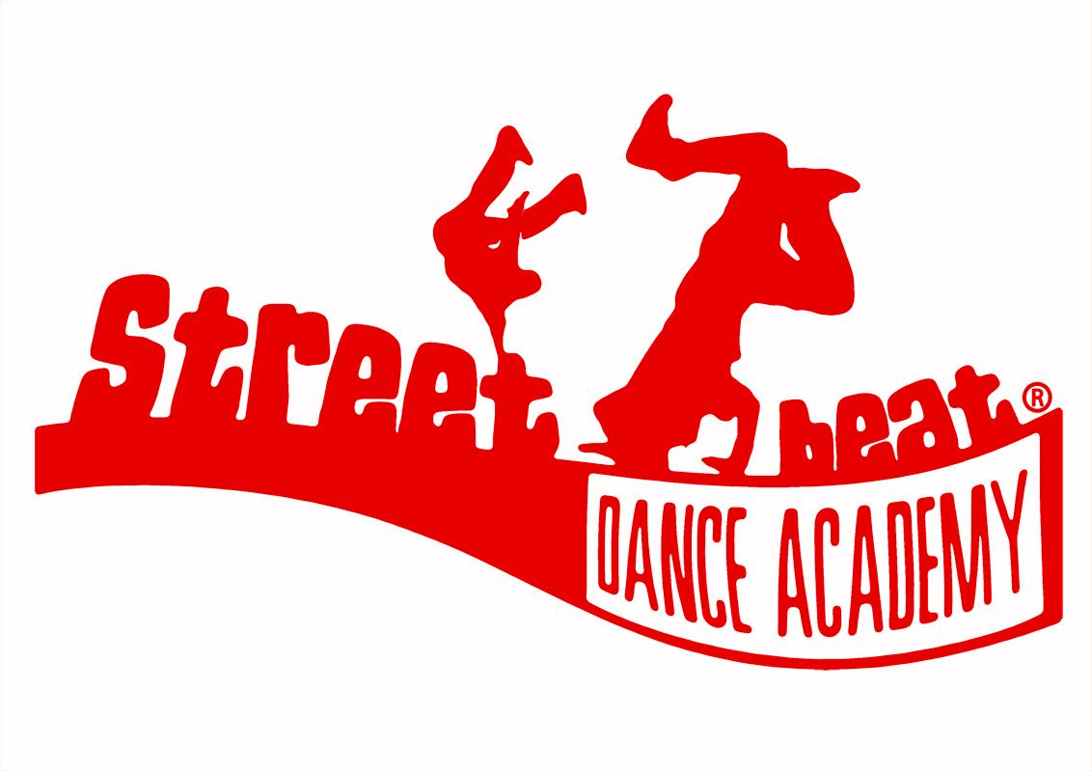
SUMMER WORKSHOPS 2017
We will be running the following workshops over summer holidays 2017!! Sign up ASAP to reserve your place! All Workshops have limited spaces available and we will work on a first come first serve basis. So book on soon to avoid disappointment!!
- Thursday 10th August – AIR TRACK @ Epworth Therlow, DN9 1JU 2.30-4.30pm -ONLY £7 – Come along to work with Jonny on our AMAZING AIR TRACK to develop your Tumbling skills!!!
- Sunday 13th August - Contemporary Technique @ Epworth Youth centre, Dn9 1EP - 10am-3pm – Contemporary dance Session with Ayisha, this sessions will focus on Technique and Learning a NEW routine. This session is partially funded by Positive activities and Costs just £5.

- Thursday 17th August – Cheer and Tumbling @ Epworth Therlow, DN9 1JU @ 2.30-4.30pm come along and learn new skills in Cheer Stunts and Tumbling!!! What a fun and exciting new style to learn!!! JUST £7

- Sunday 20th August – Creative Contemporary @ Epworth Youth centre, Dn9 1EP – 10am-3pm Contemporary dance Session with Ayisha, this sessions will be a Creative workshop – teaching you skills and techniques to develop your creative skills and working towards your own choreographic idea. This session is partially funded by Positive activities and Costs just £5.

- Thursday 24th August – POWER!!! @ Epworth Therlow, DN9 1JU @ 2.30-4.30pm – Come train with Jonny and learn new Power moves, Develop your skills and work on your POWER!!!! Only £7

To reserve your space you must return the form and payment to a staff member. Payment is non-refundable. Places will be allocated on a first come first serve bases and we have a limited number of places per workshop. Please note some workshops have a minimum number and cannot run if we do not have enough people able to take part, should this happen you will be refunded for your workshop. For more info please email Ayisha@sbacademy.co.uk or call 07955800094
-----------------------------------------------------------------------------------------------------------------------------------------------------
I (parent/ Guardian) …………………………………………….. give permission for my child (child’s name) ………………………………………………….. to attend the following Street Beat Summer workshops 2017.
Please tick the boxes of the workshops your child will be attending:

AIR TRACK – 10th Aug – Epworth Therlow -£7

CONTEMPORARY TECHNIQUE – 13th August - Epworth Youth centre - £5

CHEER AND TUMBLE – 17th Aug – Epworth Therlow - £7

CREATIVE CONTEMPORARY – 20th Aug – Epworth Youth centre - £5

POWER 24th August – Epworth Therlow - £7

Total Enclosed £………………
Email address…………………………………………………………………………….Contact Number……………………………………
Parent signed………………………………………………………………………………….Date………………………………………..

