‘Wear What You Like Day’
Friday, 7th July 2017

Please bring a forfeit suitable for the children’s tombola stall at the Summer Fayre

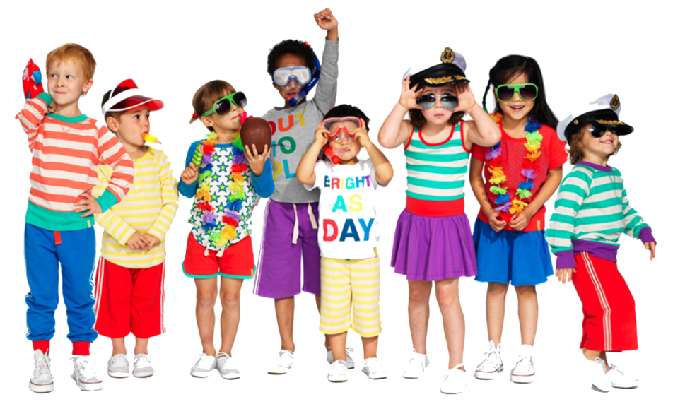
No nightwear or onesies

